Prerequisites to Understand:
- How to Perform Permission Verification for This Interface:
- The permission must exist in the kp_permission table of the mmi-admin database.
Example: INSERT INTO [dbo].[kp_permission] ([id], [type], [name], [authority_key], [sort], [status], [level], [parent_id], [uri], [micro_app_name]) VALUES (16024, 4, N'Icon Delete', N'iconDelete', 2, 1, N'2,3', 570, NULL, NULL);
- id: Unique primary key. Before adding a new one, query the current maximum primary key value and increment it by 1.
- type (1.module 2.menu 3.page 4.button)
- authority_key: Permission identifier (used for permission control in code)
- sort (default 999): If set to 1, it will be displayed as the first item at the same level in the UI.
- status (1.enable 2.disable)
- level: The user level that can use this permission.
- Assign this permission to the corresponding role. We usually use SQL to assign it to the system administrator role (role ID = 1), and other roles are assigned through the UI.Example: INSERT INTO [dbo].[kp_role_permission_mapping] ([role_id], [permission_id]) VALUES (1, 16024);
- a. If only users with this specific permission can access the interface, add the following annotation to the interface method:Example: @PreAuthorize("hasAuthority('auditLogs')")
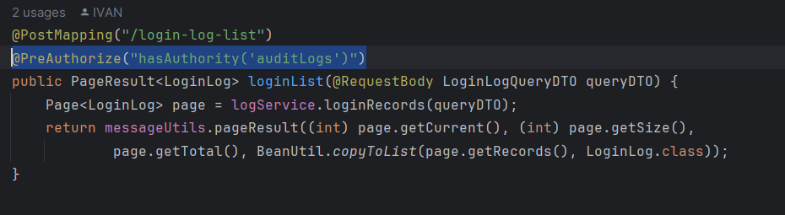
b. If users with any of multiple permissions can access the interface, add the following annotation to the method：
eg：@PreAuthorize("hasAnyAuthority('assignWorkspace','roleManagementEdit','roleManagementAdd')")
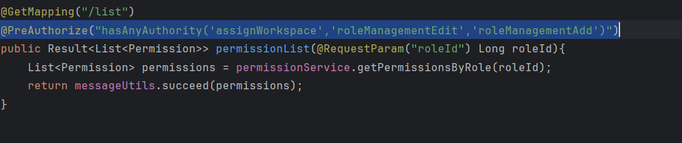

二. API Explanations:
- Get Health Status of Video Proxy (Implemented by HAProxy, no need for MMI to develop)
- MMI needs to add a health check interface for HAProxy to call to verify service availability.
You can directly add this method:
java
运行
@Operation(summary = "check service health")
@GetMapping("/health-check")
public String checkServiceHealth() {
return "OK";
}
- Get Stream License Usage
- Add a corresponding permission for this interface with parent_id=40 and type=4.
- This interface needs to call the MMI-VMS interface.
- The logic is somewhat complex; I will implement it and inform you to call it directly.
- Get Camera List
- Add a corresponding permission for this interface with parent_id=40 and type=4.
- This interface needs to call the MMI-VMS interface.
- Directly call the ChannelFeign.findChannels interface of mmi-vms-feign.
- Get Camera Schedule
- Add a corresponding permission for this interface with parent_id=40 and type=4.
- This interface needs to call the MMI-VMS interface.
- Directly call the ChannelFeign.findChannels interface of mmi-vms-feign.
- Get Camera Recording List
- Add a corresponding permission for this interface with parent_id=40 and type=4.
- This interface needs to call the MMI-VMS interface.
- For all controllers used for internal service calls, the corresponding URL of InnerXXXController must be /inner/XXXXX.
- There is an existing method ScheduleServiceImpl.getScheduleById in mmi-vms-server.
- Request Live Video Stream (RTSP)
- Add a corresponding permission for this interface with parent_id=40 and type=4.
- This interface needs to call the MMI-VMS interface.
- For all controllers used for internal service calls, the corresponding URL of InnerXXXController must be /inner/XXXXX.
- There is an existing method LiveViewServiceImpl.getLive in mmi-vms-server.
- Request Live Video Stream (WebRTC) (This should be a VMS interface)
- Request Playback Video Stream (RTSP)
- Add a corresponding permission for this interface with parent_id=40 and type=4.
- This interface needs to call the MMI-VMS interface.
- For all controllers used for internal service calls, the corresponding URL of InnerXXXController must be /inner/XXXXX.
- There is an existing method PlayBackServiceImpl.getPlayBack in mmi-vms-server.
- Request Playback Video Stream (WebRTC) (This should be a VMS interface)
- PTZ Control
- Add a corresponding permission for this interface with parent_id=40 and type=4.
- This interface needs to call the MMI-VMS interface.
- For all controllers used for internal service calls, the corresponding URL of InnerXXXController must be /inner/XXXXX.
- There is an existing method PtzServiceImpl.controlPtz in mmi-vms-server.
- Query VA Events
- Add a corresponding permission for this interface with parent_id=40 and type=4.
- This interface needs to call the MMI-Alarm interface.
- Directly call the QueryFeign.searchEventHistory interface of mmi-alarm-feign.
- Get VA Event Image
- Add a corresponding permission for this interface with parent_id=40 and type=4.
- This interface needs to call the MMI-Alarm interface.
- For all controllers used for internal service calls, the corresponding URL of InnerXXXController must be /inner/XXXXX.
- There is an existing method VapQueryServiceImpl.getImageBinaryFileById in mmi-alarm-server.
- Get Camera Snapshot (Not implemented for now)
- Add a corresponding permission for this interface with parent_id=40 and type=4.
- This interface needs to call the MMI-VMS interface.
- For all controllers used for internal service calls, the corresponding URL of InnerXXXController must be /inner/XXXXX.
- There is an existing method StreamServiceImpl.controlPtz in mmi-vms-server.
- Generate Event Video
- Add a corresponding permission for this interface with parent_id=40 and type=4.
- This interface needs to call the MMI-VMS interface.
- For all controllers used for internal service calls, the corresponding URL of InnerXXXController must be /inner/XXXXX.
- There is no existing method for this interface; I will inform you after implementation.
- Annotate Alert
- Add a corresponding permission for this interface with parent_id=40 and type=4.
- This interface needs to call the MMI-Alarm interface.
- For all controllers used for internal service calls, the corresponding URL of InnerXXXController must be /inner/XXXXX.
- There is an existing method VapQueryServiceImpl.updateAlarm in mmi-alarm-server.
- Apply Pushing VA Event Filter (Not implemented for now)

